Pokhara University

Level: Bachelor | Semester – Fall | Year : 2010
Programme: BE |  | Full Marks : 100
 |  | Pass Mark : 45
Course: Control System |  | Time : 3 hrs

Candidates are required to give their answers in their own words as far as practicable.
The figures in the margin indicate full marks.

Attempt all the questions.

1. | - A closed loop system can become unstable under certain condition. Illustrate the statement with suitable reasons.  - Obtain the force-voltage analogy of the mechanical system shown in the figure. | 7  8
2. | - Find the transfer function of the system represented by the following block diagram.  - Define Eigen Values and Eigen Vectors. Determine the transfer matrix from the state space model given below. 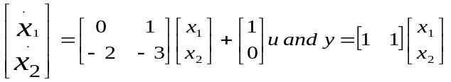 | 8  7
3. | - The open loop transfer function of a unity feedback system is given by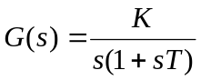, where ‘K’ and ‘T’ are positive constants. By what factor should the amplifier gain be multiplied so that the damping ratio is increased from 0.3 to 0.9.  - The block diagram of an electronic pacemaker is given in the figure below. Determine the steady state error for the unit ramp input when K = 400. Also determine the value of K for which the steady state error to a unit ramp will be 0.02. | 8  7
4. | - Plot the root locus plot for the open loop transfer function given by 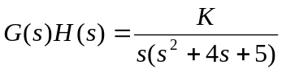  - A unity feedback control system is characterized by open loop transfer function 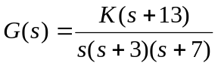. Using Routh criterion calculate the range of values of K for the system to be sable. | 10  5
5. | - Construct the bode plot for a unity feedback control system having 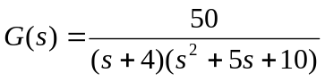  - Sketch the Nyquist diagram and determine the stability of a unity feedback system given by: 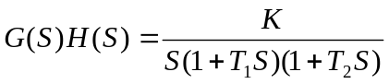 | 8  7
6. | Design a phase lead compensator, C(s) for a plant with transfer function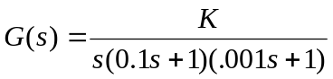, such that C(s)G(s) will meet a velocity error coefficient k_{v}= 1000 sec⁻¹ and phase margin of 45⁰. | 15
7. | Write short notes on (Any Two):  - Open loop and closed loop systems  - Effects of adding poles and zeros on transfer functions  - P controller | 2×5

